

FACULTY OF ENGINEERING AND TECHNOLOGY

A REPORT ON NUMERICAL METHODS , CREATING AND PROCESSING A STRUCTURAL ARRAY OF LEAVES ,IMPORTING AND CREATING TABLES IN MATLAB.

COURSE UNIT: COMPUTER PROGRAMMING

LECTURER: Mr. MASERUKA BENEDICTO
SUBMITTED BY

GROUP 4

DATE OF SUBMISSION: …06/10/2026…
DECLARATION
We hereby certify and confirm that the information in this report is out of our own efforts, research and it has never been submitted in any institution for any academic award
NAME | REGISTRATION NUMBER | PROGRAM
WEMBABAZI IVAN | BU/UG/2025/4414 | AMI
ATUHAIRWE DEOGRATIUS | BU/UG/2025/4409 | AMI
NSAMBA GODWIN | BU/UP/2025/1960 | AMI
AYEBALE LAMEX | BU/UG/2025/4410 | AMI
WAMUWAYA SULAIMAN | BU/UP/2025/2146 | AMI
NAKANWAGI CATHERINE | BU/UG/2025/4412 | AMI
APPROVAL
We are presenting this report which has been written and produced under our efforts. We carried out a group assignment in MATLAB in which a structural array describing ten different leaves was created, and each leaf image was processed to obtain a binary mask and basic geometric measurements.
ACKNOWLEDGEMENT
First and foremost, we would like to thank the Almighty God for giving us the strength to carry on with our research as Group 4. We would love to extend our gratitude to all the persons with whose help we managed to make it this far
The willingness of each one of us to invest time and provide constructive feedback has been immensely valuable in this assignment.
Finally, we would like to express our gratitude to all the sources and references that have been cited in this report
DEDICATION.
We dedicate this report to all the individuals especially Group 4 members, who have been there for us in the process of formulating and producing this report.
To our lecturer Mr. Maseruka Benedicto whose guidance and expertise have been invaluable, your mentorship and insightful feedback have shaped our understanding.
ABSTRACT
This report presents a MATLAB group assignment on structural arrays and basic image processing. A structural array named Leaves was created to store the scientific name, common name, shape, margin, venation and photograph of ten different leaves. Each photograph was converted to grayscale, threshold cleaned and measured, and the resulting mask and measurements were stored in the same array.
The structural array stored mixed text, image and numeric data without difficulty. The threshold-based segmentation, however, depended strongly on the image background and gave dependable masks only for some of the leaves.
Table of Contents
1 INTRODUCTION 10
2 OBJECTIVES 10
3 METHODOLOGY 10
4 1. Newton-Raphson Method 30
4.1 A. Solution using a FOR loop 30
4.1.1 Flowchart 30
4.1.2 Pseudo code 30
4.1.3 MATLAB code 31
4.1.4 Output (same for both versions) 31
4.2 B. Solution using a WHILE loop 32
4.2.1 Flowchart 32
4.2.2 Pseudo code 32
4.2.3 MATLAB code 32
4.2.4 Output (same for both versions) 33
5 2. Secant Method 33
5.1 A. Solution using a FOR loop 34
5.1.1 Flowchart 34
5.1.2 Pseudo code 34
5.1.3 MATLAB code 35
5.1.4 Output (same for both versions) 35
5.2 B. Solution using a WHILE loop 36
5.2.1 Flowchart 36
5.2.2 Pseudo code 36
5.2.3 MATLAB code 36
5.2.4 Output (same for both versions) 37
6 3. Runge-Kutta Method (4th Order) 37
6.1 A. Solution using a FOR loop 38
6.1.1 Flowchart 38
6.1.2 Pseudo code 38
6.1.3 MATLAB code 39
6.1.4 Output (same for both versions) 39
6.2 B. Solution using a WHILE loop 40
6.2.1 Flowchart 40
6.2.2 Pseudo code 40
6.2.3 MATLAB code 41
6.2.4 Output (same for both versions) 41

LIST OF ACRONYMS/ ABBREVIATIONS.
- RGB - Red, Green, Blue.
- MATLAB - Matrix Laboratory.

INTRODUCTION
A structural array in MATLAB stores related records in a single variable, with every element holding the same named fields. This is useful when each item being described has several attributes of different types, such as text, images and numbers. This report covers a group assignment in which such an array was used to organise information about ten leaves collected by the group, and in which each leaf photograph was processed with basic image-processing functions. The report covers:
- The design of a structural array named Leaves with fields for the scientific name, common name, shape, margin, venation and image of each leaf.
- The conversion of each image to a binary mask and the measurement of its area, perimeter, eccentricity and solidity.
- The display of the original images and masks, and a summary table of the whole array.
For each part, this report presents the method, the MATLAB code, and the results obtained.

OBJECTIVES
- To create a structural array that stores descriptive attributes and the photograph of ten different leaves.
- To process each leaf image into a binary mask using grayscale conversion, thresholding, hole filling and removal of small objects.
- To extract geometric measurements from each mask and store them in the structural array.
- To display the original images, processed masks and a summary table, and to discuss how reliable the results are.

METHODOLOGY
ASSN 1
Number 1
%% Student information
%%entering our details
StudentName = {'Atuhairwe Deogratious';'Wembabazi Ivan';'Ayebale Lamex';'Nsamba Godwin';'Nakanwagi Catherine'; ‘Wamuwaya Sulaiman’ };
Tribe = {'Munyoro'; 'Munyoro'; 'Munyankole'; 'Musoga'; 'Muganda’; 'Mutooro’};
Age = {22;21;23;20;19;24};
Marks ={85;80;75;81;78;80};
Association = {'BUKISA';'BUKISA';'BUWUSA';'BUWESA';'BANKOSA'
‘BANKOSA’};
Hostel = {'Mabonga';'Mabonga';'Luna';'Jamica';'Machio'’Alshadia’};
Friends = {'Joseph';'Moses';'Grace';'Charity';'Jovia'’jane’};
Hobbies = {'Swimming';'Dancing';'Sleeping';'Singing';'Eating';’Outing’};
%% Creating Table
StudentsData=table(StudentName,Tribe,Age,Marks,Association,Hostel,Friends,Hobbies);
%% Importing same data from Exel
StudentsDataExel=readtable("C:\Users\Leno\Desktop\AMI STUDENTS.xlsx");
disp(StudentsDataExel);
%% Exporting to Exel
Filename = ("MatlabAMIGroup4.xlsx");
writetable(StudentsDataExel,Filename);
%% Plotting Marks against names and saving using code
figure;
bar(StudentsDataExel.StudentsName, StudentsDataExel.Marks);
xlabel('Names');
ylabel('Marks');
title('Name vs Marks');
exportgraphics(gca, 'StudentPlot.png', 'Resolution', 300);

Number 2
%% GPA and CGPA for students
% Grading
% A+ = 4.00 A- = 3.67 B+ = 3.33 B = 3.00 B- = 2.67
% C+ = 2.33 C = 2.00 C- = 1.67 D+ = 1.33 D = 1.00 F = 0.00

%% Students' grading in semester 1 and 2

students(1).Name = "Atuhairwe Deogratius";
students(1).Semester(1).Name = "Semester 1";
students(1).Semester(1).Courses = {
"Mechanics I", 3, "A";
"Programming Language.", 3, "A-";
"Materials II", 3, "B+";
"Electronics", 2, "A"
};
students(1).Semester(2).Name = "Semester 2";
students(1).Semester(2).Courses = {
"Mechanics II", 3, "B+";
"Autocad", 3, "A";
"Maths II", 3, "B";
"Fluid Mechanics", 3, "A-"
};

students(2).Name = "Wembabazi Ivan";
students(2).Semester(1).Name = "Semester 1";
students(2).Semester(1).Courses = {
"Mechanics I", 3, "B";
"Programming language", 3, "B+";
"Materials II", 3, "C+";
"Electronics", 2, "B-"
};
students(2).Semester(2).Name = "Semester 2";
students(2).Semester(2).Courses = {
"Mechanics II", 3, "B";
"Autocad", 3, "B+";
"Maths II", 3, "A-";
"Fluid Mechanics", 3, "B"
};
students(3).Name = "Nsamba Godwin";
students(3).Semester(1).Name = "Semester 1";
students(3).Semester(1).Courses = {
"Mechanics I", 3, "A";
"Programming Language", 3, "A-";
"Materials II", 3, "B+";
"Electronics", 2, "B"
};
students(3).Semester(2).Name = "Semester 2";
students(3).Semester(2).Courses = {
"Mechanics II", 3, "B+";
"Autocad", 3, "A";
"Maths II", 3, "B";
"Fluid Mechanics", 3, "A-" };
students(4).Name = "Ayebale Lamex";
students(4).Semester(1).Name = "Semester 1";
students(4).Semester(1).Courses = {
"Mechanics I", 3, "B";
"Programming Language", 3, "A-";
"Materials II", 3, "B+";
"Electronics", 2, "B"
};
students(4).Semester(2).Name = "Semester 2";
students(4).Semester(2).Courses = {
"Mechanics II", 3, "B+";
"Autocad", 3, "A";
"Maths II", 3, "B";
"Fluid Mechanics", 3, "A-"
};
students(5).Name = "Nakanwagi Chatherine";
students(5).Semester(1).Name = "Semester 1";
students(5).Semester(1).Courses = {
"Mechanics I", 3, "A";
"Programming Lamguage.", 3, "B-";
"Materials II", 3, "B+";
"Electronics", 2, "B"
};
students(5).Semester(2).Name = "Semester 2";
students(5).Semester(2).Courses = {
"Mechanics II", 3, "B+";
"Autocad", 3, "A";
"Maths II", 3, "B";
"Fluid Mechanics", 3, "A-"
};
students(6).Name = " Wamuwaya Sulaiman";
students(6).Semester(1).Name = "Semester 1";
students(6).Semester(1).Courses = {
"Mechanics I", 3, "B";
"Programming Language", 3, "A-";
"Materials II", 3, "B+";
"Electronics", 2, "B"
};
students(6).Semester(2).Name = "Semester 2";
students(6).Semester(2).Courses = {
"Mechanics II", 3, "B+";
"Autocad", 3, "A";
"Maths II", 3, "B";
"Fluid Mechanics", 3, "A-"

%% PROCESS ALL STUDENTS
for s = 1:numel(students)
fprintf('==================================================\n');
fprintf('Student: %s\n', students(s).Name);
fprintf('==================================================\n');

totalQualityPoints = 0;
totalCreditHours = 0;

for sem = 1:numel(students(s).Semester)
courses = students(s).Semester(sem).Courses;
[semGPA, semCredits, semQP] = calculateGPA(courses);

totalQualityPoints = totalQualityPoints + semQP;
totalCreditHours = totalCreditHours + semCredits;
cgpaSoFar = totalQualityPoints / totalCreditHours;

fprintf('\n%s:\n', students(s).Semester(sem).Name);
printCourseTable(courses);
fprintf(' -> Semester Credit Hours : %.1f\n', semCredits);
fprintf(' -> Semester GPA : %.3f\n', semGPA);
fprintf(' -> CGPA (through this sem): %.3f\n', cgpaSoFar);

students(s).Semester(sem).GPA = semGPA;
end

students(s).CGPA = totalQualityPoints / totalCreditHours;
fprintf('\n>>> Final CGPA for %s: %.3f\n\n', students(s).Name, students(s).CGPA);
end

%% SUMMARY TABLE
fprintf('==================================================\n');
fprintf('SUMMARY\n');
fprintf('==================================================\n');
fprintf('%-20s %-10s\n', 'Student', 'CGPA');
for s = 1:numel(students)
fprintf('%-20s %-10.3f\n', students(s).Name, students(s).CGPA);
end

%% FUNCTIONS

function [gpa, totalCredits, totalQP] = calculateGPA(courses)
% calculateGPA computes GPA for one semester.
% courses is an N x 3 cell array: {Name, CreditHours, LetterGrade}
totalCredits = 0;
totalQP = 0;
for i = 1:size(courses,1)
credit = courses{i,2};
grade = courses{i,3};
point = gradeToPoint(grade);
totalQP = totalQP + (point * credit);
totalCredits = totalCredits + credit;
end
gpa = totalQP / totalCredits;
end

function point = gradeToPoint(grade)
% gradeToPoint converts a letter grade to grade points (4.0 scale).
% Edit this table to match your institution's exact policy.
switch upper(strtrim(grade))
case "A", point = 4.00;
case "A-", point = 3.67;
case "B+", point = 3.33;
case "B", point = 3.00;
case "B-", point = 2.67;
case "C+", point = 2.33;
case "C", point = 2.00;
case "C-", point = 1.67;
case "D+", point = 1.33;
case "D", point = 1.00;
case "F", point = 0.00;
otherwise
error("Unknown grade '%s'. Update gradeToPoint().", grade);
end
end

function printCourseTable(courses)
% printCourseTable displays courses, credits, grade and points nicely
fprintf(' %-20s %-8s %-6s %-8s\n', 'Course', 'Credits', 'Grade', 'Points');
for i = 1:size(courses,1)
name = courses{i,1};
credit = courses{i,2};
grade = courses{i,3};
point = gradeToPoint(grade);
fprintf(' %-20s %-8.1f %-6s %-8.2f\n', name, credit, grade, point);
end
end
ASSN 2
%% Importing Our Data From Assignment One
StudentData=readtable("C:\Users\HP ZBOOK 15 G3\Desktop\AMI STUDENTS.xlsx");
%% Line Graph
figure;
plot(StudentData.Age,StudentData.Marks);
xlabel('Age');
ylabel('Marks');
title('Line graph showing Marks against Age');
grid on;
%% Bar Graph
figure;
bar(StudentData.StudentsName,StudentData.Marks);
xlabel("StudentName");
ylabel("Marks");
title("Bar graph showing Marks against StudentName");
grid on;
%% scatter plot
figure;
scatter(StudentData.Age,StudentData.Marks);
xlabel("Age");
ylabel('Marks');
title('Scatter plot showing Marks against Age');
grid on;
%% Horizontal Bar graph
c%% Stem plot
figure;
stem(StudentData.Age,StudentData.Marks);
xlabel("Age");
ylabel('Marks');
title('Stem plot showing Marks against Age');
grid on;
%% step plot
figure;
stairs(StudentData.Age,StudentData.Marks);
xlabel("Age");
ylabel('Marks');
title('Step plot showing Marks against Age');
grid on;
%% Error bar Bar Plot

figure;
errorbar(StudentData.Age,StudentData.Marks);
errors=rand(19,23);
xlabel("Age");
ylabel('Marks');
title('Error bar plot showing Marks against Age');
grid on;
%% Area plot
figure;
area(StudentData.Age,StudentData.Marks);
xlabel("Age");
ylabel('Marks');
title('Area plot showing Marks against Age');
grid on;
%% Histogram
figure;
histogram(StudentData.Marks);
xlabel("StudentName");
ylabel('Marks');
title('Histogram showing Marks against StudentName');
grid on,
%% Pareto chart
figure;
pareto(StudentData.Marks);
xlabel("Age");
ylabel('Marks');
title('Pareto chart showing Marks against Age');
grid on;
%% Box plot
figure;
boxplot(StudentData.Marks);
xlabel("Age");
ylabel('Marks');
title('Pareto chart showing Marks against Age');
grid on;
%% pie chart
figure
pie(StudentData.Marks);
title('Pie chart showing students marks');
grid on;
%% pie chart with percentage lables

figure
lables=(StudentData.StudentsName);
pie(StudentData.Marks, lables);
title('Pie chart showing students marks');
grid on;
%% Logarithmic plot
figure;
semilogx(StudentData.Age,StudentData.Marks);
title('semilogx plot showing Marks against Age');
grid on;

ASSN 3
% Diffent types of leaves
%%empty structure array
leafData = struct('Type', {}, 'Properties', {}, 'OriginalImage', {}, 'ProcessedImage', {});

%% LEAF 1
leafData(1).Type = 'simple entire';

% Properties
leafData(1).Properties = struct('Venation', 'Net-like (Reticulate)','Margin', 'entire','Shape', 'Oval/Lanceolate');

% Loading the original image
leafData(1).OriginalImage = imread('C:\Users\HP ZBOOK 15 G3\Desktop\sinmple leaves\entire.jpg');

% Processing the image
grayLeaf = rgb2gray(leafData(1).OriginalImage);
binaryMask = imbinarize(grayLeaf, 'adaptive');
cleanedMask = imfill(binaryMask, 'holes');
leafEdges = edge(grayLeaf, 'Canny');

% Store the final processed image
leafData(1).ProcessedImage = leafEdges;

%% LEAF 2
leafData(2).Type = 'simple reticulate';
leafData(2).Properties = struct('Venation', 'Parallel','Margin', 'Entire (Smooth)', 'Shape', 'Linear/Elongated');

leafData(2).OriginalImage = imread("C:\Users\HP ZBOOK 15 G3\Desktop\sinmple leaves\reticulate.jpg");

% Process Leaf 2
grayLeaf2 = rgb2gray(leafData(2).OriginalImage);
leafData(2).ProcessedImage = imbinarize(grayLeaf2);
%% LEAF 3
leafData(3).Type = 'lobed';
leafData(3).Properties = struct('Venation', 'network','Margin', 'Entire (Smooth)', 'Shape', 'broadly ovate');

leafData(3).OriginalImage = imread("C:\Users\HP ZBOOK 15 G3\Desktop\sinmple leaves\lobed.jpg");

% Process Leaf 3
grayLeaf3 = rgb2gray(leafData(3).OriginalImage);
enhanced=imadjust(grayLeaf3);
leafData(3).ProcessedImage = imbinarize(enhanced);
%% LEAF 4
leafData(4).Type = 'simple serrated';
leafData(4).Properties = struct('Venation', 'network','Margin', 'Serrated (rough)', 'Shape', 'ovate');

leafData(4).OriginalImage = imread("C:\Users\HP ZBOOK 15 G3\Desktop\sinmple leaves\simple serrated.jpg");

% Process Leaf 4
grayLeaf4 = rgb2gray(leafData(4).OriginalImage);
leafData(4).ProcessedImage = imbinarize(grayLeaf4);
%% LEAF 5
leafData(5).Type = 'parallel';
leafData(5).Properties = struct('Venation', 'Parallel','Margin', 'Entire (Smooth)', 'Shape', 'Linear/Elongated');

leafData(5).OriginalImage = imread("C:\Users\HP ZBOOK 15 G3\Desktop\sinmple leaves\parallel.jpg");

% Process Leaf 5
grayLeaf5 = rgb2gray(leafData(5).OriginalImage);
leafData(5).ProcessedImage = imbinarize(grayLeaf5);
%% LEAF 6
leafData(6).Type = 'simple reticulate';
leafData(6).Properties = struct('Venation', 'network','Margin', 'Entire (Smooth)', 'Shape', 'ovate');

leafData(6).OriginalImage = imread("C:\Users\HP ZBOOK 15 G3\Desktop\compound leaves\Bipinnate.jpg");

% Process Leaf 6
grayLeaf6 = rgb2gray(leafData(6).OriginalImage);
leafData(6).ProcessedImage = imbinarize(grayLeaf6);
%% LEAF 7
leafData(7).Type = 'compound palmate';
leafData(7).Properties = struct('Venation', 'Parallel','Margin', 'Entire (Smooth)', 'Shape', 'palmate');

leafData(7).OriginalImage = imread("C:\Users\HP ZBOOK 15 G3\Desktop\compound leaves\palmate.jpg");

% Process Leaf 7
grayLeaf7 = rgb2gray(leafData(7).OriginalImage);
leafData(7).ProcessedImage = imbinarize(grayLeaf7);
%% LEAF 8
leafData(8).Type = 'unipinnate';
leafData(8).Properties = struct('Venation', 'network','Margin', 'Entire (Smooth)', 'Shape', 'ovate');

leafData(8).OriginalImage = imread("C:\Users\HP ZBOOK 15 G3\Desktop\compound leaves\Unipinnate.jpg");

% Process Leaf 8
grayLeaf8 = rgb2gray(leafData(8).OriginalImage);
leafData(8).ProcessedImage = imbinarize(grayLeaf8);
%% DISPLAYING THE LEAVES
disp('Leaf Structure Array Created Successfully:');
disp(leafData);

% results for the first leaf
figure;
subplot(1,2,1);
imshow(leafData(1).OriginalImage);
title(['Original: ', leafData(1).Type]);
subplot(1,2,2);
imshow(leafData(1).ProcessedImage);
title('Processed ');
% results for the second leaf
figure;
subplot(1,2,1);
imshow(leafData(2).OriginalImage);
title(['Original: ', leafData(2).Type]);
subplot(1,2,2);
imshow(leafData(2).ProcessedImage);
title('Processed (simple reticulate)');
% results for the third leaf
figure;
subplot(1,2,1);
imshow(leafData(3).OriginalImage);
title(['Original: ', leafData(3).Type]);
subplot(1,2,2);
imshow(leafData(3).ProcessedImage);
title('Processed');
% results for the forth leaf
figure;
subplot(1,2,1);
imshow(leafData(4).OriginalImage);
title(['Original: ', leafData(4).Type]);
subplot(1,2,2);
imshow(leafData(4).ProcessedImage);
title('Processed');
% results for the fifth leaf
figure;
subplot(1,2,1);
imshow(leafData(5).OriginalImage);
title(['Original: ', leafData(5).Type]);
subplot(1,2,2);
imshow(leafData(5).ProcessedImage);
title('Processed');
% results for the sixth leaf
figure;
subplot(1,2,1);
imshow(leafData(6).OriginalImage);
title(['Original: ', leafData(6).Type]);
subplot(1,2,2);
imshow(leafData(6).ProcessedImage);
title('Processed');
% results for the seventh leaf
figure;
subplot(1,2,1);
imshow(leafData(7).OriginalImage);
title(['Original: ', leafData(7).Type]);
subplot(1,2,2);
imshow(leafData(7).ProcessedImage);
title('Processed');
% results for the eighth leaf
figure;
subplot(1,2,1);
imshow(leafData(8).OriginalImage);
title(['Original: ', leafData(8).Type]);
subplot(1,2,2);
imshow(leafData(8).ProcessedImage);
title('Processed');

ASSN 4
Numerical Methods using FOR and WHILE Loops
Newton-Raphson, Secant and Runge-Kutta: flowcharts, pseudo code and MATLAB code
Each method is solved on one standard problem and written twice, once with a for loop and once with a while loop. For every version you will find the flowchart, the pseudo code, the MATLAB code and the expected output.

1. Newton-Raphson Method
Find the real root of f(x) = x³ − 2x − 5 with initial guess x0 = 2, tolerance 10⁻⁶.
Formula: x(n+1) = x(n) − f(x(n)) / f′(x(n)), where f′(x) = 3x² − 2

A. Solution using a FOR loop

Flowchart
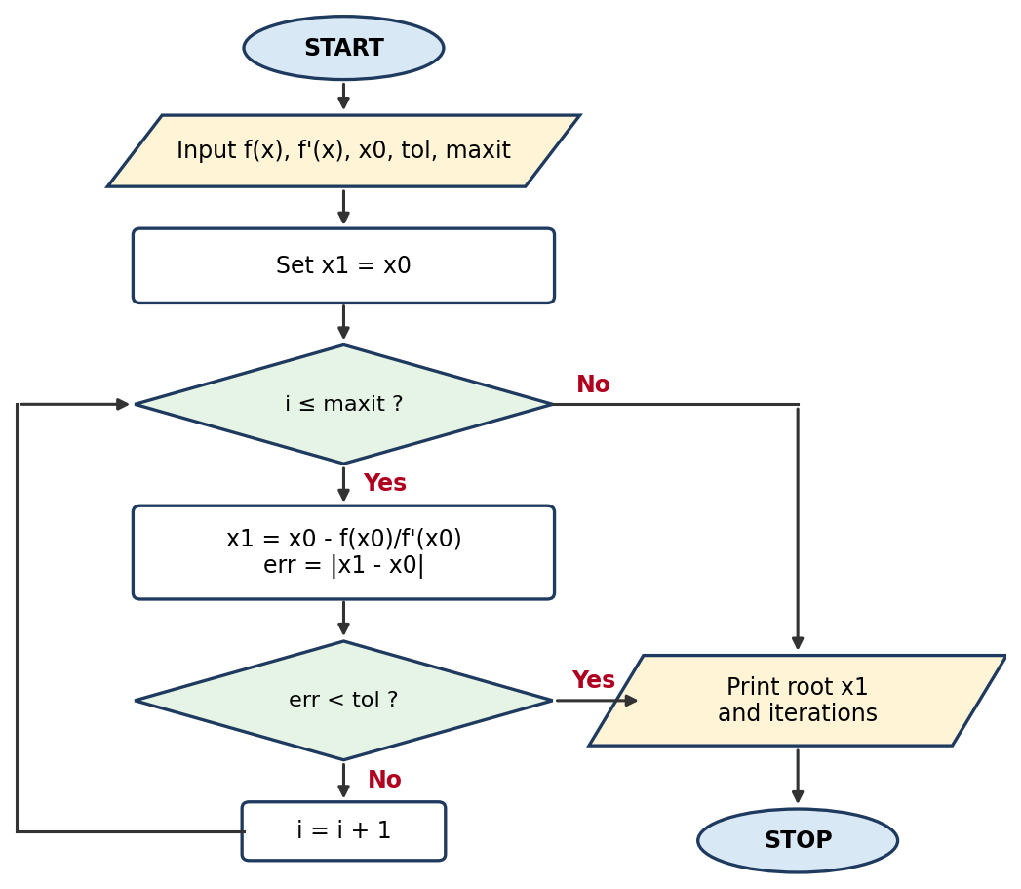

Pseudo code
START
INPUT f(x), f'(x), x0, tol, maxit
FOR i = 1 TO maxit
x1 = x0 - f(x0) / f'(x0)
err = |x1 - x0|
PRINT i, x1, err
IF err < tol THEN
BREAK
ENDIF
x0 = x1
ENDFOR
PRINT root x1 and number of iterations
STOP

MATLAB code
% Newton-Raphson method using a FOR loop
clc; clear;

f = @(x) x^3 - 2*x - 5;
df = @(x) 3*x^2 - 2;
x0 = 2; tol = 1e-6; maxit = 50;

for i = 1:maxit
x1 = x0 - f(x0)/df(x0);
err = abs(x1 - x0);
fprintf('Iter %2d: x = %.8f error = %.2e\n', i, x1, err);
if err < tol
break
end
x0 = x1;
end
fprintf('Root = %.6f found in %d iterations\n', x1, i);

Output (same for both versions)
Iter 1: x = 2.10000000 error = 1.00e-01
Iter 2: x = 2.09456812 error = 5.43e-03
Iter 3: x = 2.09455148 error = 1.66e-05
Iter 4: x = 2.09455148 error = 1.56e-10
Root = 2.094551 found in 4 iterations

B. Solution using a WHILE loop

Flowchart
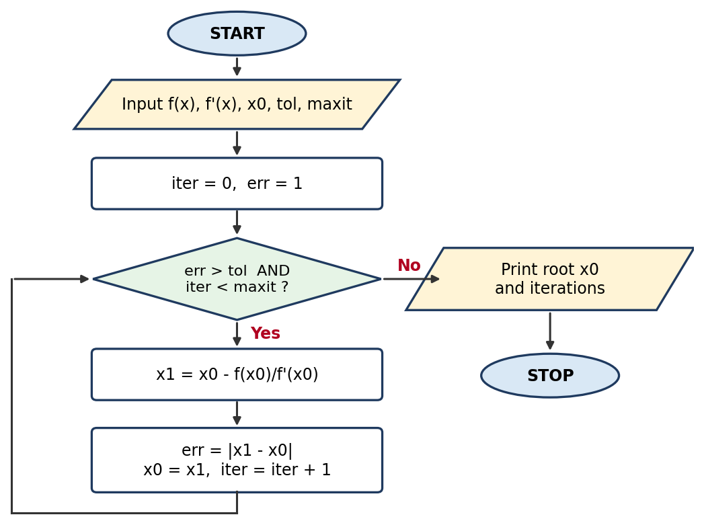

Pseudo code
START
INPUT f(x), f'(x), x0, tol, maxit
iter = 0
err = 1
WHILE err > tol AND iter < maxit
x1 = x0 - f(x0) / f'(x0)
err = |x1 - x0|
x0 = x1
iter = iter + 1
PRINT iter, x0, err
ENDWHILE
PRINT root x0 and number of iterations
STOP

MATLAB code
% Newton-Raphson method using a WHILE loop
clc; clear;

f = @(x) x^3 - 2*x - 5;
df = @(x) 3*x^2 - 2;
x0 = 2; tol = 1e-6; maxit = 50;
iter = 0; err = 1;

while err > tol && iter < maxit
x1 = x0 - f(x0)/df(x0);
err = abs(x1 - x0);
x0 = x1;
iter = iter + 1;
fprintf('Iter %2d: x = %.8f error = %.2e\n', iter, x0, err);
end
fprintf('Root = %.6f found in %d iterations\n', x0, iter);

Output (same for both versions)
Iter 1: x = 2.10000000 error = 1.00e-01
Iter 2: x = 2.09456812 error = 5.43e-03
Iter 3: x = 2.09455148 error = 1.66e-05
Iter 4: x = 2.09455148 error = 1.56e-10
Root = 2.094551 found in 4 iterations

2. Secant Method
Find the real root of f(x) = cos(x) − x with initial guesses x0 = 0 and x1 = 1, tolerance 10⁻⁶.
Formula: x(n+1) = x(n) − f(x(n)) · (x(n) − x(n−1)) / (f(x(n)) − f(x(n−1)))

A. Solution using a FOR loop

Flowchart
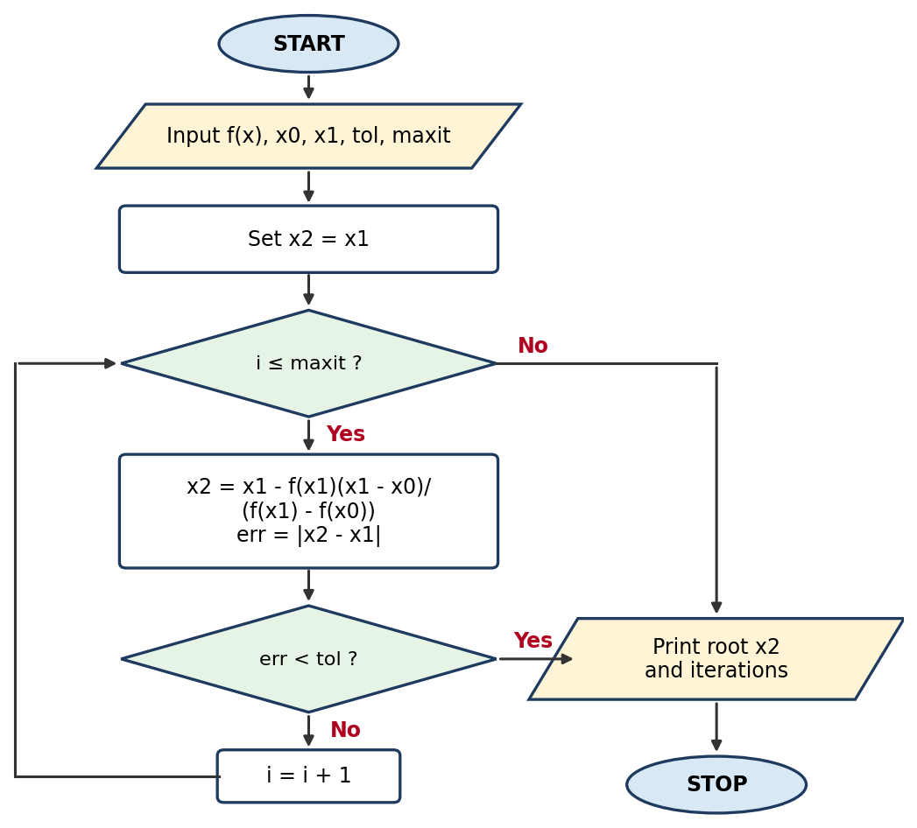

Pseudo code
START
INPUT f(x), x0, x1, tol, maxit
FOR i = 1 TO maxit
x2 = x1 - f(x1)*(x1 - x0) / (f(x1) - f(x0))
err = |x2 - x1|
PRINT i, x2, err
IF err < tol THEN
BREAK
ENDIF
x0 = x1
x1 = x2
ENDFOR
PRINT root x2 and number of iterations
STOP

MATLAB code
% Secant method using a FOR loop
clc; clear;

f = @(x) cos(x) - x;
x0 = 0; x1 = 1; tol = 1e-6; maxit = 50;

for i = 1:maxit
x2 = x1 - f(x1)*(x1 - x0)/(f(x1) - f(x0));
err = abs(x2 - x1);
fprintf('Iter %2d: x = %.8f error = %.2e\n', i, x2, err);
if err < tol
break
end
x0 = x1;
x1 = x2;
end
fprintf('Root = %.6f found in %d iterations\n', x2, i);

Output (same for both versions)
Iter 1: x = 0.68507336 error = 3.15e-01
Iter 2: x = 0.73629900 error = 5.12e-02
Iter 3: x = 0.73911936 error = 2.82e-03
Iter 4: x = 0.73908511 error = 3.42e-05
Iter 5: x = 0.73908513 error = 2.11e-08
Root = 0.739085 found in 5 iterations

B. Solution using a WHILE loop

Flowchart
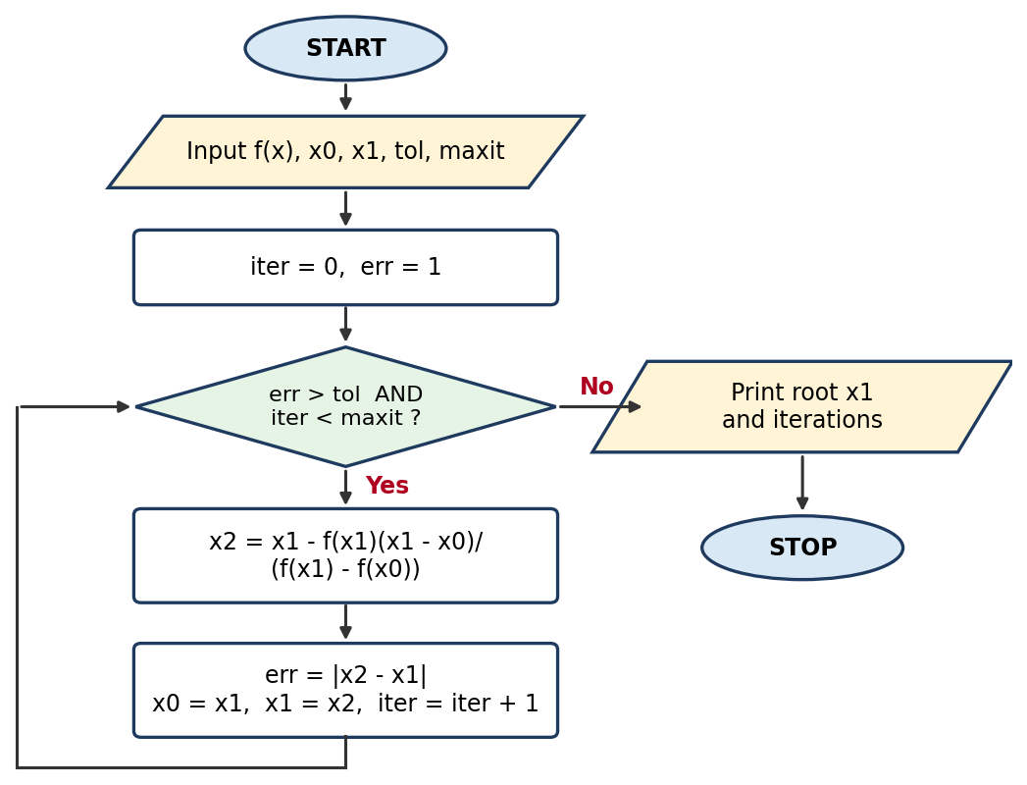

Pseudo code
START
INPUT f(x), x0, x1, tol, maxit
iter = 0
err = 1
WHILE err > tol AND iter < maxit
x2 = x1 - f(x1)*(x1 - x0) / (f(x1) - f(x0))
err = |x2 - x1|
x0 = x1
x1 = x2
iter = iter + 1
PRINT iter, x1, err
ENDWHILE
PRINT root x1 and number of iterations
STOP

MATLAB code
% Secant method using a WHILE loop
clc; clear;

f = @(x) cos(x) - x;
x0 = 0; x1 = 1; tol = 1e-6; maxit = 50;
iter = 0; err = 1;

while err > tol && iter < maxit
x2 = x1 - f(x1)*(x1 - x0)/(f(x1) - f(x0));
err = abs(x2 - x1);
x0 = x1;
x1 = x2;
iter = iter + 1;
fprintf('Iter %2d: x = %.8f error = %.2e\n', iter, x1, err);
end
fprintf('Root = %.6f found in %d iterations\n', x1, iter);

Output (same for both versions)
Iter 1: x = 0.68507336 error = 3.15e-01
Iter 2: x = 0.73629900 error = 5.12e-02
Iter 3: x = 0.73911936 error = 2.82e-03
Iter 4: x = 0.73908511 error = 3.42e-05
Iter 5: x = 0.73908513 error = 2.11e-08
Root = 0.739085 found in 5 iterations

3. Runge-Kutta Method (4th Order)
Solve dy/dx = x + y with y(0) = 1 over 0 ≤ x ≤ 1 using step size h = 0.1. The exact solution y = 2eˣ − x − 1 is used for comparison.
Formula: y(n+1) = y(n) + (h/6)(k1 + 2k2 + 2k3 + k4), with k1 = f(x,y), k2 = f(x+h/2, y+h·k1/2), k3 = f(x+h/2, y+h·k2/2), k4 = f(x+h, y+h·k3)

A. Solution using a FOR loop

Flowchart
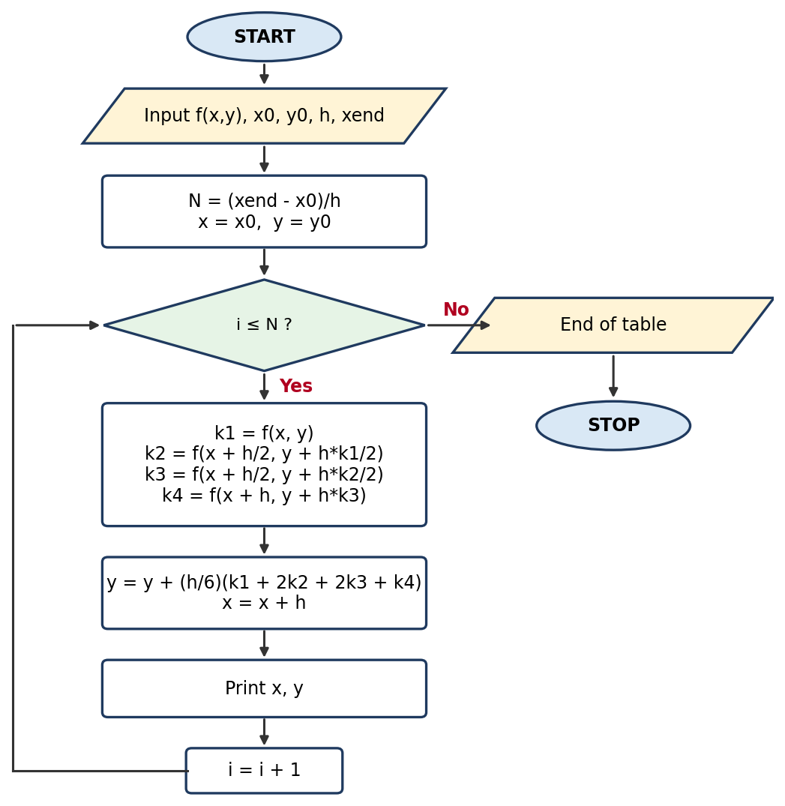

Pseudo code
START
INPUT f(x,y), x0, y0, h, xend
N = (xend - x0) / h
x = x0
y = y0
FOR i = 1 TO N
k1 = f(x, y)
k2 = f(x + h/2, y + h*k1/2)
k3 = f(x + h/2, y + h*k2/2)
k4 = f(x + h, y + h*k3)
y = y + (h/6)*(k1 + 2*k2 + 2*k3 + k4)
x = x + h
PRINT x, y
ENDFOR
STOP

MATLAB code
% 4th-order Runge-Kutta method using a FOR loop
clc; clear;

f = @(x,y) x + y;
x0 = 0; y0 = 1; h = 0.1; xend = 1;
N = round((xend - x0)/h);

x = x0; y = y0;
fprintf('%6s %12s %12s\n', 'x', 'y (RK4)', 'y (exact)');
for i = 1:N
k1 = f(x, y);
k2 = f(x + h/2, y + h*k1/2);
k3 = f(x + h/2, y + h*k2/2);
k4 = f(x + h, y + h*k3);
y = y + (h/6)*(k1 + 2*k2 + 2*k3 + k4);
x = x + h;
fprintf('%6.2f %12.6f %12.6f\n', x, y, 2*exp(x) - x - 1);
end

Output (same for both versions)
x y (RK4) y (exact)
0.10 1.110342 1.110342
0.20 1.242805 1.242806
0.30 1.399717 1.399718
0.40 1.583648 1.583649
0.50 1.797441 1.797443
0.60 2.044236 2.044238
0.70 2.327503 2.327505
0.80 2.651079 2.651082
0.90 3.019203 3.019206
1.00 3.436559 3.436564

B. Solution using a WHILE loop

Flowchart
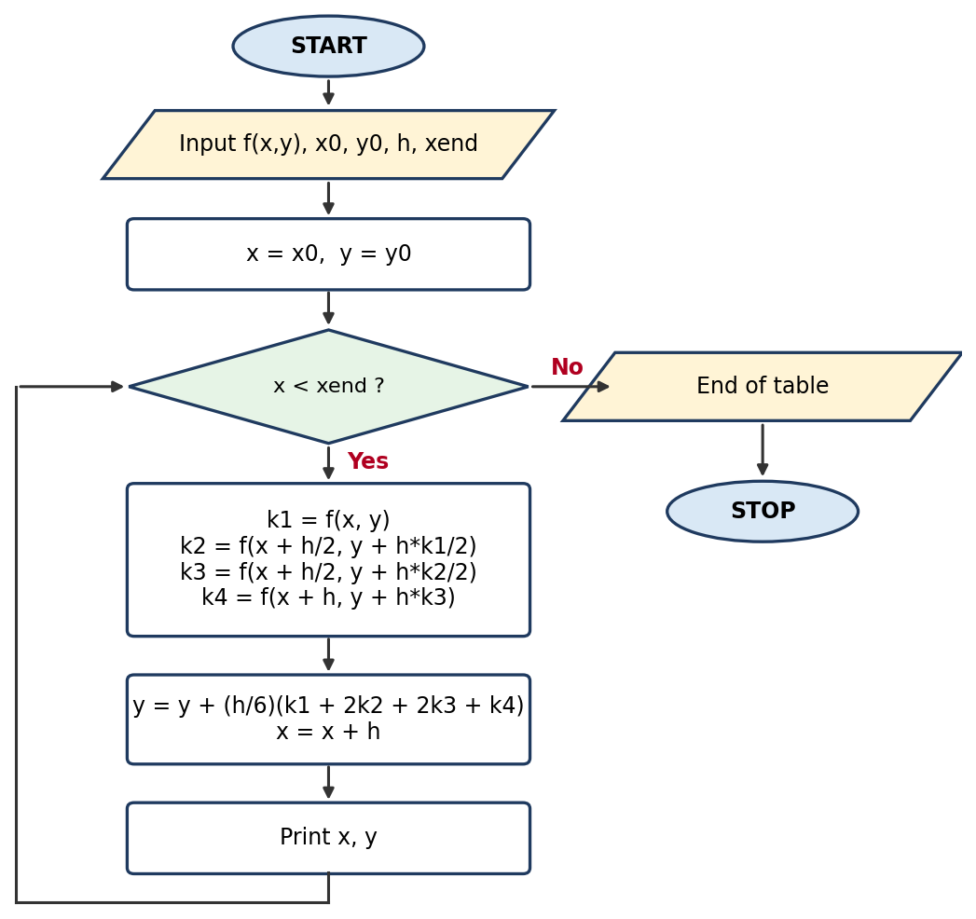

Pseudo code
START
INPUT f(x,y), x0, y0, h, xend
x = x0
y = y0
WHILE x < xend
k1 = f(x, y)
k2 = f(x + h/2, y + h*k1/2)
k3 = f(x + h/2, y + h*k2/2)
k4 = f(x + h, y + h*k3)
y = y + (h/6)*(k1 + 2*k2 + 2*k3 + k4)
x = x + h
PRINT x, y
ENDWHILE
STOP

MATLAB code
% 4th-order Runge-Kutta method using a WHILE loop
clc; clear;

f = @(x,y) x + y;
x0 = 0; y0 = 1; h = 0.1; xend = 1;

x = x0; y = y0;
fprintf('%6s %12s %12s\n', 'x', 'y (RK4)', 'y (exact)');
while x < xend - 1e-10
k1 = f(x, y);
k2 = f(x + h/2, y + h*k1/2);
k3 = f(x + h/2, y + h*k2/2);
k4 = f(x + h, y + h*k3);
y = y + (h/6)*(k1 + 2*k2 + 2*k3 + k4);
x = x + h;
fprintf('%6.2f %12.6f %12.6f\n', x, y, 2*exp(x) - x - 1);
end

Output (same for both versions)
x y (RK4) y (exact)
0.10 1.110342 1.110342
0.20 1.242805 1.242806
0.30 1.399717 1.399718
0.40 1.583648 1.583649
0.50 1.797441 1.797443
0.60 2.044236 2.044238
0.70 2.327503 2.327505
0.80 2.651079 2.651082
0.90 3.019203 3.019206
1.00 3.436559 3.436564
Conclusion
In conclusion, this MATLAB assignment provided practical experience in using MATLAB commands and programming techniques to solve engineering and mathematical problem. The exercises improved our understanding of calculations, data manipulation, plotting,and the use of MATLAB functions.

